Simmer Design Document

Updated as of February 27th, 2022

# Description

Simmer is a 2D cooking-focused RPG that centers around a single playable character honing their cooking skills and learning new recipes as they make their way to becoming a well-experienced chef. The player will attempt to transition between working a day job to a full-time chef by practicing in their spare time, spending what money they can for supplies, equipment and learning about new cuisines. The player will have to manage their time, prioritize different skills, and explore new recipes to make it in the culinary world.

## Money

Money can be collected by selling food items the player creates on their own. Money can be spent on groceries to create dishes. The player is provided with a minimum amount of money each day after going to work.

## Real-Time Cooking

Cooking itself will initiate when the player selects the recipe they want to begin in the kitchen HUB. To prevent the player from committing to a recipe they cannot complete, there are certain skill and ingredient checks to prevent the player from wasting time. The player then navigates the kitchen taking items and equipment to each station. Timers will be displayed over time-sensitive stations (such as a pot of soup on the stove) and the player will have to execute each step of the recipe.

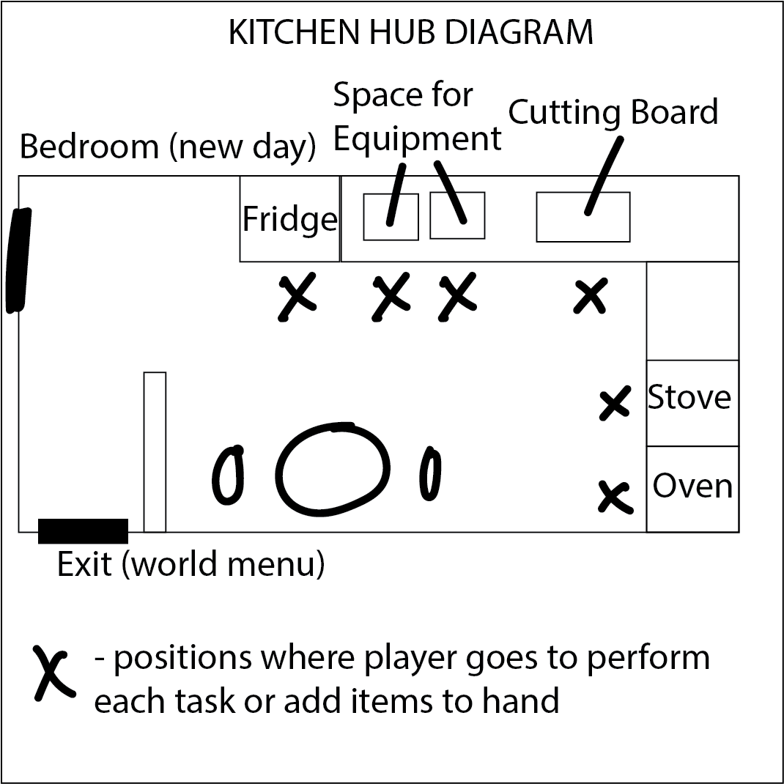

## Environment

The player will maintain all of their cooking requirements (ingredients, equipment, and appliances) at home. This will be the main HUB where the player will return to cook, experiment, and improve skills. The player will be able to leave their home and travel to:

* Farmer’s Market - to select from a smaller range of high quality, more expensive ingredients

## NPC

The social interaction with NPCs will encompass requesting dishes while providing the recipe to complete it. These quests will be a linear progression for each individual NPC.